AI Project Kickoff and Dataset
Project Title: PCOS Prediction in Early Age
Submitted By: Manahil Asif & Malaika Majeed
Objective:
The goal of this project is to develop an AI-based solution that can predict the likelihood of Polycystic Ovary Syndrome (PCOS) in young women at an early age. By identifying potential PCOS risks early, the app aims to help in the timely management of infertility, miscarriage, and other health issues associated with PCOS. This prediction model aims to provide medical professionals with a valuable tool for early diagnosis, enabling better treatment planning.
Team Members & Assigned Roles:
Malaika Majeed:
- Data Analyst: Responsible for collecting, analyzing, and preparing data for model training. This includes data cleaning and preprocessing, feature selection, data normalization and standardization, and ensuring the quality of the dataset.
- Documentations: Responsible for managing project documentation and ensuring proper reporting. This includes coordinating tasks, tracking project progress, and managing timelines to ensure the smooth execution of the project
Manahil Asif:
- Programmer: Developing, training, testing, and evaluating the machine learning model to ensure accuracy.
- UI/UX: Designing an intuitive and visually appealing user interface to enhance user experience and accessibility.
Problem Statement:
Polycystic Ovary Syndrome (PCOS) is a common hormonal disorder affecting women of reproductive age, yet it is often diagnosed late due to the gradual onset of symptoms. This condition involves infrequent, irregular, or prolonged menstrual periods, along with elevated levels of male hormones (androgens). The ovaries develop numerous small collections of fluid — called follicles — and may fail to regularly release eggs.
The early signs of PCOS can be subtle and might not be immediately recognized. If left undiagnosed, PCOS can lead to serious long-term health problems, such as infertility, diabetes, and cardiovascular issues. Early diagnosis and intervention are crucial for managing symptoms and improving quality of life.
By leveraging machine learning algorithms, this tool will provide early warning signs to healthcare professionals, allowing for better patient care and reducing the long-term effects of the condition.
Ratio of PCOS Patients in Pakistan:
In Pakistan, 52% of women suffer from PCOS (BMC Women’s Health), contributing to infertility—22% of women face infertility, with 4% primary and 18% secondary.
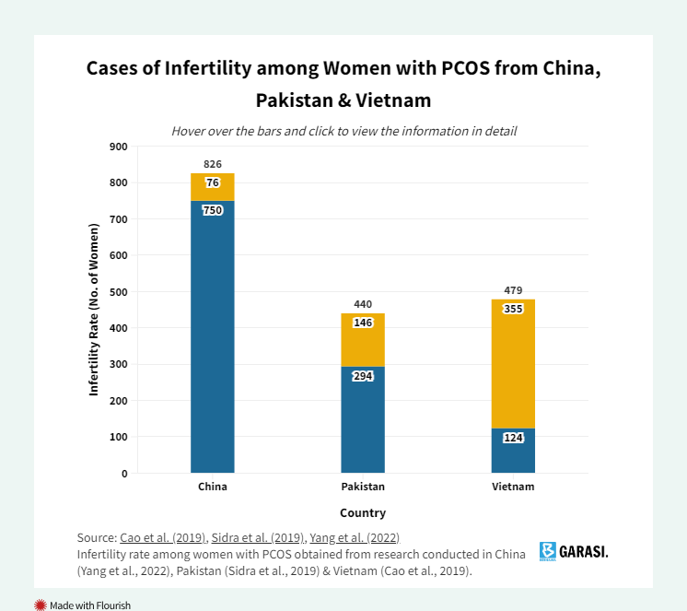
Societal Benefits:
How predicting PCOS in early ages will benefit the society?
1. Reduce Healthcare costs: It can help prevent diseases such as type 2 diabetes, cardiovascular diseases, and infertility, thereby saving costs that would otherwise be spent on treating these conditions.
2. Improved Reproductive Health: Early detection will reduce the need for assisted reproductive technologies and their associated costs.
3. Increased Productivity Healthier individuals contribute more effectively to the workforce, reducing absenteeism and enhancing overall economic productivity.
Why AI is a good approach for solving this problem?
Detection through Pattern Recognition: AI can analyze complex datasets to identify patterns that may be indicative of early stages of PCOS. AI examines variables such as menstrual cycle, hormone changes, lifestyle factors and it can predict the likelihood of developing PCOS before any clinical symptoms may become pronounced.
Continuous training and learning: AI continuously learns form new data and train their predictive capabilities over time. This ensures that they remain updated with latest researches and innovations in medicine and provide most effective solutions.
Tools & Technologies:
- Programming Languages: Python
- Libraries & Frameworks:
scikit-learn (for machine learning), pandas (for data manipulation), NumPy (for numerical computations), TensorFlow (for deep learning models), Matplotlib/Seaborn (for data visualization)
- Development Platforms:
Google Colab / Jupyter Notebook (for prototyping and experimentation), Visual Studio Code, Canva (for designing)
- Deployment:
Flask / Django (for creating a web app interface)
Data Preparation
Data Source:
year = {2020},
publisher = {kaggle},
journal = {Kaggle Dataset}

The dataset utilized for this project is the "Polycystic Ovary Syndrome (PCOS)" dataset available on Kaggle, curated by Prasoon Kottarathil, published in 2020. It comprises clinical and medical data collected from 541 female patients, aimed at facilitating the prediction of PCOS. The dataset is structured into two files: one containing data from patients with infertility issues and another without. These files have been merged to form a comprehensive dataset, ensuring a diverse representation of patient profiles. The dataset includes a wide range of features such as demographic information, clinical measurements, hormonal levels, and ultrasound findings, providing a robust foundation for developing predictive models.
In addition to its diversity, the dataset has been utilized in various research studies focusing on PCOS prediction using machine learning techniques. For instance, studies have applied algorithms like Random Forest, Support Vector Machines, and Logistic Regression to this dataset, achieving notable accuracy in PCOS prediction. These studies underscore the dataset's utility in developing effective predictive models and its contribution to advancing research in this domain.
This dataset contains all physical and clinical parameters to determine PCOS and infertility related issues. Data is collected from 10 different hospital across Kerala, India.
Dataset: https://www.researchgate.net/publication/370409423_Prediction_and_Analysis_of_Polycystic_Ovary_Syndrome_Using_Machine_Learning
Data Cleaning:
To prepare the dataset for analysis, the following preprocessing steps will be undertaken:​
- Handling Missing Values: Identify and address any missing or null values through appropriate imputation techniques or by removing incomplete records, depending on the extent and nature of the missing data.​
- Removing Duplicates: Ensure the dataset contains unique entries by eliminating any duplicate records that may skew the analysis.​
- Standardizing Data Formats: Convert categorical variables into numerical formats using encoding techniques such as one-hot encoding or label encoding, facilitating their use in machine learning models.​
- Feature Selection: Analyze the relevance of each feature to the prediction of PCOS and retain those that contribute significantly to model performance, thereby reducing dimensionality and improving efficiency.
Data Description:
Source: https://www.kaggle.com/datasets/prasoonkottarathil/polycystic-ovary-syndrome-pcos
The dataset consists of 541 records with 41 attributes, encompassing a mix of numerical and categorical data. Key features include:
Total Rows: 541
Total Columns: 45

Feature Name | Abb | Description
Patient File No. |  | Patient file number (unique identifier)
Polycystic Ovary Syndrome | PCOS | Class label (determine if the patient has this syndrome or not)
Age | AGE | Patient’s age in years
Weight | WEIGHT | Patient’s weight in KG
Height | HEIGHT | Patient’s height in CM
Body Mass Index | BMI | Body mass index of the patient (height/weight)
Blood Group | BG | Patients belong to which blood group (A+, A−, B+, B−, O+, O−, AB+, AB−)
Pulse Rate | PR | Heartbeat per minute
Respiration Rates | RR | Respiration rates per minute
Hemoglobin | HB | Number of red blood cells in patient’s body
Cycle | CYCLE | Length of the menstrual cycle
Cycle Length | CL | Number of days of a cycle
Marriage Status | MS | Number of years since marriage
Pregnant | P | Pregnant status
No. of Abortions | AB | No. of abortions
I Beta-HCG | BETA_I | Amount of human chorionic gonadotropin
Beta Healthy Singleton Pregnancy | BETA_II | Beta HCG level is indication of 100 mIU/ml
 |  | about 16 days after ovulation,
Follicle-Stimulating Hormone | FSH | Attributes ranging from 0.3 to 10.0 mIU/mL indicate if are still menstruating or have undergone menopause
Luteinizing Hormone | LH | Chemical agitator that stimulates the reproductive system
Follicle-Stimulating Hormone/Luteinizing Hormone | FSH/LH | Ratio of FSH and LH
Hip Size | HIP | Size of hip in inches
Waist Size | WAIST | Size of waist in inches
Waist-Hip Ratio | HIP_RATIO | Waist size proportion to hip
Thyroid-Stimulating Hormone | TSH | Amount of TSH in the blood
Anti-Mullerian Hormone | AMH | Plays a key role in developing a baby’s sex organs while in the womb
Prolactin levels | PRL | Prolactin levels in women’s bodies
Vitamin D | VIT_D3 | Vitamin D levels
Progesterone Levels | PRG | Progesterone levels
Random Blood Sugar | RBS | Value of random blood sugar (RBS) test
Weight Gain | WG | Test to check if the patient gains weight
Hair Growth | HG | Test to check if a patient has hair growth
Skin Darkening | SD | Test to check the appearance of darkness in skin
Hair Loss | HL | Test to check hair loss
Pimples | PIMPLES | Pimple issues
Fast Food | FF | Check if fast food part of the diet
Reg.Exercise | RE | Check if patient exercises on a regular basis
Blood Pressure Systolic | BP_ SYSTOLIC: | Amount of pressure in the arteries when the heart is contracting
Blood Pressure Diastolic | BP_ Diastolic | Amount of pressure in the arteries while the heart is resting in between heart beats

This rich set of features allows for comprehensive analysis and model development aimed at early detection of PCOS.
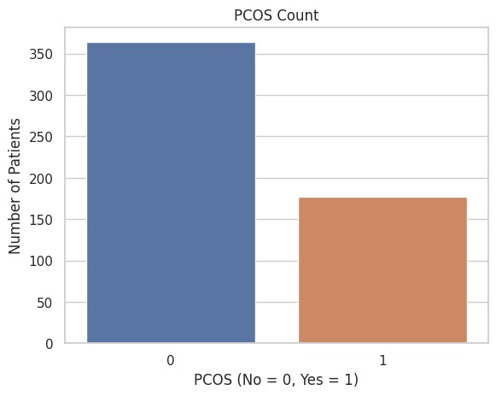
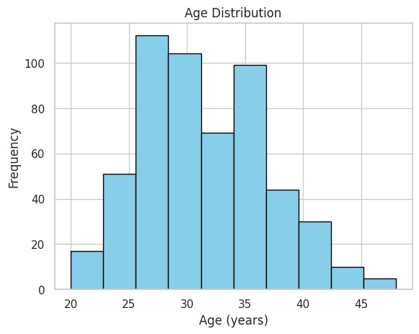
Initial Data Visualization:
Identifying common age groups in datasets suffering from PCOS
PCOS Count in Dataset
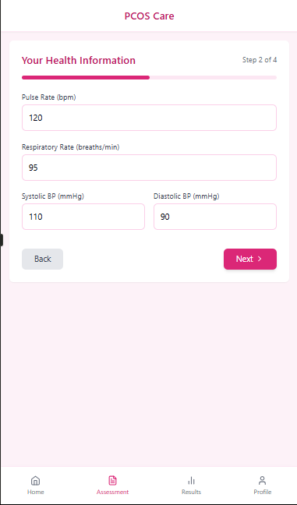
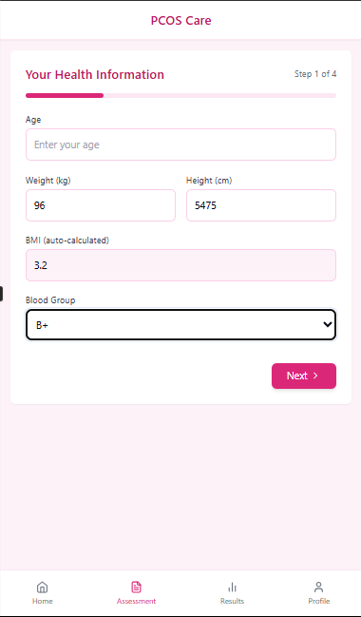

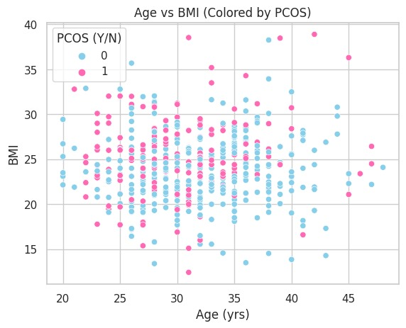
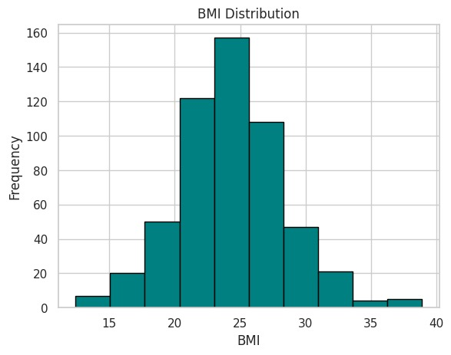
App UI/UX:
Age vs BMI - Shows if there's any link between age and body weight (BMI).
BMI Distribuition - Shows if most people are underweight, normal, or overweight.

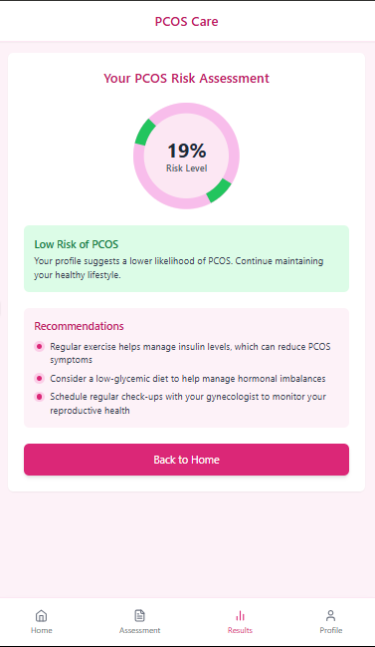
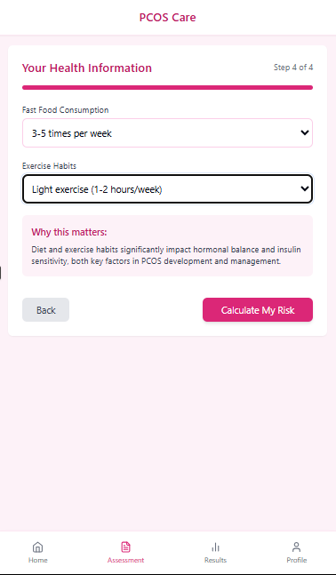
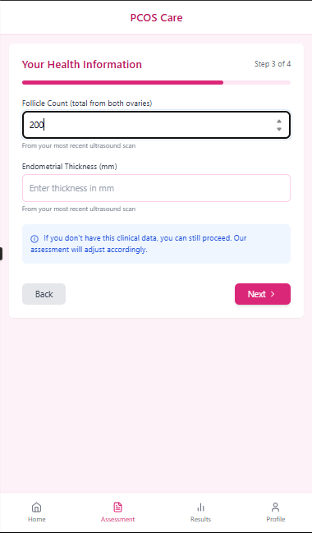
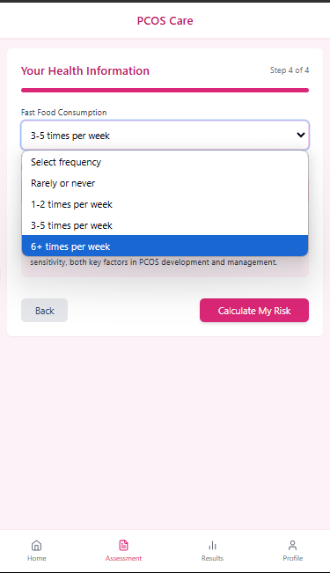
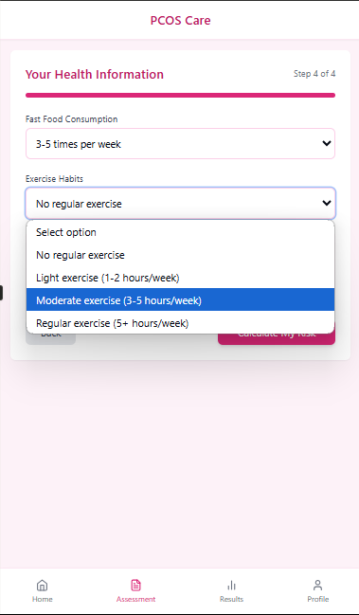

References
https://pmc.ncbi.nlm.nih.gov/articles/PMC10137609/
https://pmc.ncbi.nlm.nih.gov/articles/PMC10137609/#sec3-diagnostics-13-01506

